Your Dance Pros

# Jim Lewis

Although Jim retired from his work as a Federal civil servant in January 2018, his schedule hasn’t slowed down. He now divides most of his time between managing his rental properties and embracing his passion for horse racing at the track in North Sydney.

Jim always loved to dance, but says it took some coaxing to get him to say yes to dancing in front of a large audience!  But he is super happy he did and is pleased to partner with Lori Kennedy in this Dancing with the Stars for Hospice event.

Like Lori, Jim is dancing for several loved ones from his sphere who were supported with hospice and palliative care at end of life.  Jim says he’s hoping his loved ones will be watching the event from Heaven, as he and Lori welcome all the divine intervention they can get as they attempt to wow you on the dance floor!

# Cynthia Vokey

Cynthia is a Merritt nominated and award-winning choreographer and dance educator from Cape Breton.

With over 20 years of experience in many forms of dance, Cynthia began dancing at the age of 5 spending her formative years training at the Cape Breton School of the Arts under the direction of Susan Gallop. During her early years as a competitive dancer, she completed the highest examination level through the Associated Dance Arts for Professional Teachers and was the only dancer east of Montreal to do so at that time. She was also chosen, at the age of 15, to travel to Spain with the Candance National Dance Team.

Into adulthood, with dance education of great importance to Cynthia, she completed intensive programs at Toronto Dance Theatre, Broadway Dance Centre and obtained her teaching certificate through the Associated Dance Arts for Professional Teachers. For the last 5 years Cynthia has served on the Board of Directors for Dance Nova Scotia and held the President’s role for a term. Cynthia also works for Cape Breton University (CBU) and is a proud CBU alumnus. To date, Cynthia has choreographed over 20 stage productions for the Highland Arts, Savoy and Boardmore Theatres and in 2019/2020 was chosen to be the Chrysalis Choreographer at Neptune Theatre.

Cynthia resides in Sydney with her husband Johnathan and their children, Pearl and Theodore. She and her family understand the importance of supporting hospice and palliative care and are proud to play a small part in raising funds for a very worthy cause. She had the great pleasure of participating in the 2019 Dancing with the Stars with her dance partner and colleague CBU President, David C. Dingwall.  In 2023 her husband, Johnathan, participated as a star in Dancing with dance coach Susan Gallop. This year’s edition of Dancing with the Stars will feature Cynthia and her sister Andrea as coaches to their dance partner and Dad, Bill.

# Andrea Vokey

Andrea enrolled in dance classes at the Cape Breton School of the Arts under the direction of Susan Gallop at just 2 years of age. She now boasts 28 years of experience in many styles of dance including tap, jazz, ballet, lyrical, and musical theatre. Andrea is an ADAPT certified dance teacher and has been teaching dance for the past thirteen years with local dance schools and the Highland Arts Theatre’s HAT Academy programs.

Andrea has also choreographed productions at the Highland Arts Theatre, the Savoy Theatre and the Boardmore Theatre at Cape

Breton University. Theatre credits include, Holiday on Christmas Island, and Little Shop of Horrors (HAT), Rocky Horror (Savoy Theatre), and Oliver (Boardmore Theatre).

Andrea has performed in Beauty and the Beast, The Nutcracker, Grease (Savoy Theatre), Heart of Steel, Rotary Show and Cheers to 10 Years (Highland Arts Theatre). Andrea has also had the privilege of attending and performing at the past two Dancing with the Stars productions in group dance guest appearances. This year, Andrea is thrilled to be partnered with her father Bill along with her sister Cynthia to help raise funds for hospice and palliative care which are causes near and dear to her heart.

# Kyle Hunter

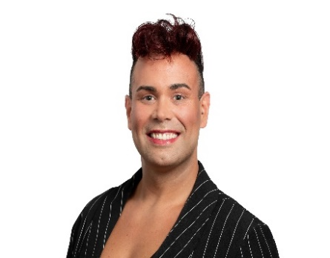Kyle has been sharing his love of dance with students at D&R Dance for the past 12 years. As a competitive dancer with 16 years of experience, Kyle has had opportunities to learn his craft under the direction of Denise Jardine and through his participation in workshops led by other well-known choreographers.

With experience in Hip-Hop, Contemporary, Musical Theatre, Tap and Jazz, Kyle in previous years has been involved in a variety of theatre productions at the Savoy Theatre and the Highland Art’s Theatre.

In addition, Kyle currently cheers for Cape Power Cheer, the longest running program in Cape Breton. Kyle had not one but two opportunities to not only represent Cape Breton but Canada by competing the IASF Cheerleading World's in bother 2023 and 2024 where be place 8th in all Canadian teams and then placed 5th in all Canadian teams in 2024.

Kyle loves working to support children with special needs and behaviourial issues and is employed with the Cape Breton Centre of Education as a Teacher’s Assistant with plans to further his education to become a teacher.

Kyle is very excited to be dancing with Lisa Turnbull Roach and raising money for a cause that is going to help so many people within the community. At a young age it was always instilled in Kyle to give back and is passionate to help others within his means.

# Denise Jardine

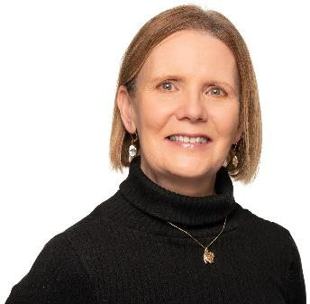Denise is the owner and operator of D&R Dance Ltd, with classes offered in North Sydney, Sydney and Dominion. She is proud to be continuing the legacy of Doris MacDonald and her husband Allen who founded MacDonald Dance Academy in 1948, making this the school’s 76th year of introducing the children of Cape Breton to the wonderful world of dance.

Denise is very excited to be dancing in her 3rd Dancing with the Stars with her partner this year, Dr Ron MacCormick in support of hospice and palliative care in the community.

**Ankit Wadhwa**

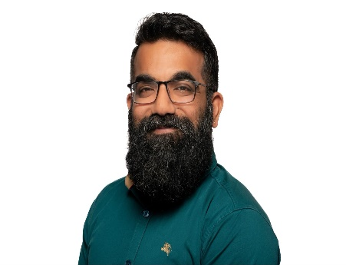Ankit**,** a recent MBA graduate**,** realized his passion for dance while in California in 2008 and moved to Cape Breton in 2022 to attend Cape Breton University. Since arriving in Cape Breton, Ankit began teaching Bhangra fitness at the YMCA and started the Island Bhangra dance group while balancing full-time studies and work.

Bhangra is a vibrant and energetic dance form originating from the Punjab region of India.  Traditionally it is performed during harvest celebrations.  Known for its lively beats and dynamic movements, Bhangra combines rhythm, joy, and high energy, making it a fun and engaging workout.

Always community focused, Ankit is involved in the organization and hosting of various multi-cultural events in Cape Breton. He is especially honoured to give back to the community through his participation in the Dancing with the Stars fundraiser with dance partner Harman Singh. Ankit and Harman will be assisted by a graduate of Bhangra dance, Udayan Moudgil, who will choregraph their dance routine.

# Danielle Korem

Danielle, with a background in physical activity and a bit of ballet in her youth, has always had a love of movement. For her, dancing is not just fun—it’s therapeutic, a way to connect with herself and others through movement.

When the opportunity came up to join this year’s Dancing with the Stars fundraiser, Danielle knew she had to say yes. It was a chance to give back to the community that means so much to her, and as an added bonus, get to meet some amazing new people along the way.

Danielle is excited to step onto the dance floor and embrace the challenge with dance partner, Travis Stone, all while supporting a great cause!

# Ryan Davis

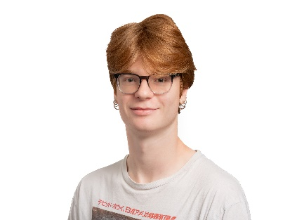Ryan has danced competitively in various styles of dance for 10 years under Northside Dance in Florence during which time his team and instructors taught him how to push hard to achieve his dancing goals.

Recently, following years of competition, Ryan began teaching dance at Impact Dance in Sydney. Ryan loves sharing his knowledge of what he has been taught by others with his students. As an entertainer during the first Dancing with the Stars fundraiser, Ryan is now excited to hit the stage as a pro with dance partner, Lisa MacEachern.

After years of being away from the stage, Ryan is pleased to be part of this year’s Dancing with the Stars in support of hospice and palliative care. An amazing cause through which funds are raised to support the needs of so many people in the community.

# Susan Gallop

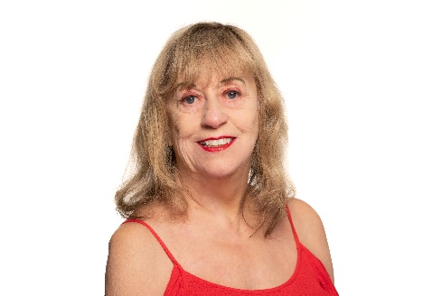Dancing since she was three years old and teaching for over 50 years, Susan has shared her love of dance and performing with thousands of Cape Breton’s children.

As the former owner and operator of the Cape Breton School of the Arts, Susan, has performed in the original Rotary Shows, the Festival on the Bay productions, numerous local dinner theatres, the Savoy Theatre’s annual Nutcracker production and various shows at the Highland Arts Theatre.

Susan is a member of the Association of Dance Arts for Professional Teachers and is still teaching today, offering workshops to local children as well as producing routines for Northside Dance, her daughter Kim’s dance school, in Florence. As a dance pro in previous Dancing with the Stars for Hospice events, Susan is especially pleased this year to hit the dance floor with her son, Darren, in support of a cause of great importance for the community.